# JavaScript for Front-End – Regular Exam Company Codex

You have been tasked to create a simple Front-End application, which generates **official work emails** for **new employees**. The client is a certain company, which has requested anonymity. However, what is interesting, is that they choose you – a junior front-end freelancer (or at least, you will prove to be one after you finish this project).

## Task

The task is split into **2 sub-tasks**:

* A simple but fancy **web page design**.
* A simple but dynamic **web page functionality**.

The clients are understanding people, and they understand that you are quite novice as a developer, so they are willing to accept **ONLY** the **web page design** (without **functionality**) or **ONLY** the **web page functionality** (without **design**), if you are **unable** to **implement** one or the other.

## Overview

### Web Page Design

The web page should look like this **WITHOUT design**:

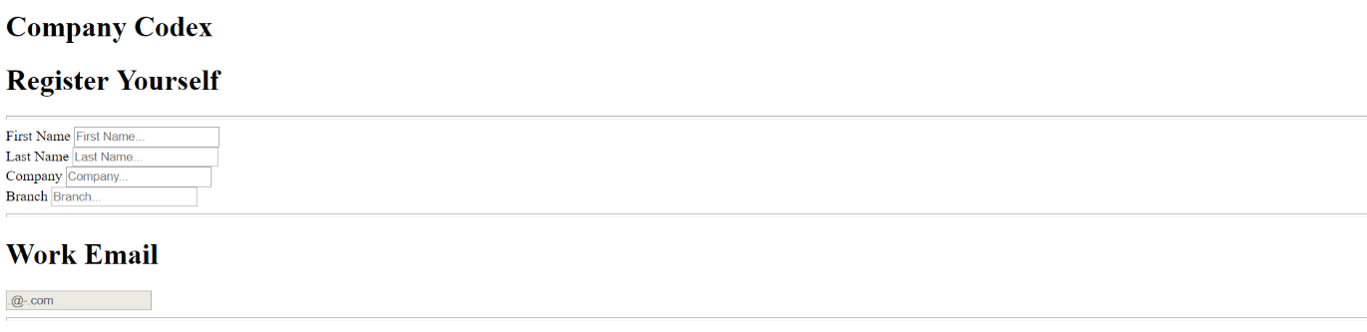

The web page should look like this **WITH design**:

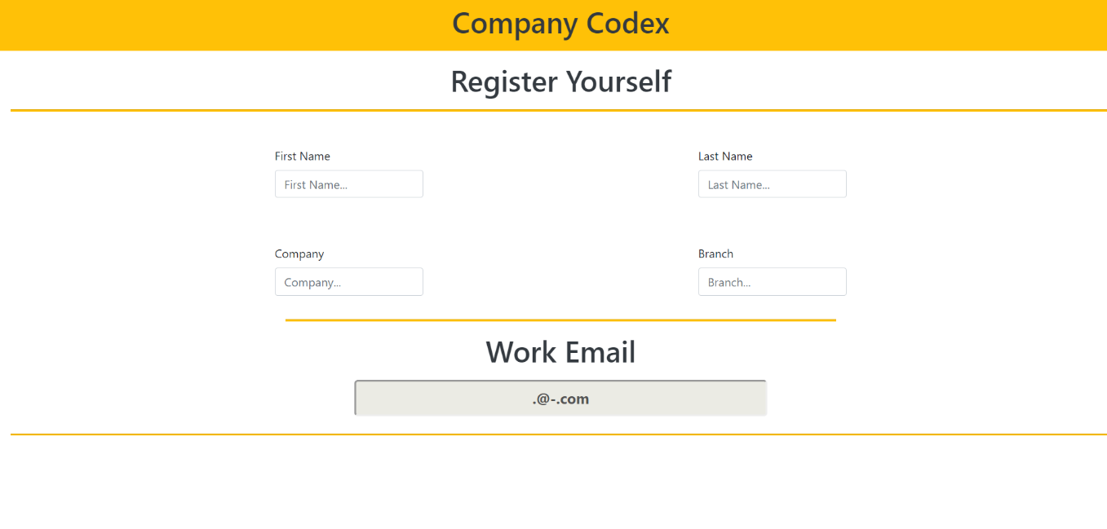

### Web Page Functionality

The application you must implement contains a **4 text input fields** which are fully functional, and **1 text input field**, which is disabled.

The 4 input fields contain **employee data**, with information about:

* **First Name**
* **Last Name**
* **Company**
* **Branch**

The **5-th** (the disabled) input field’s **value** should be **formatted** as an **official work email**,  
depending on the **values** of the **4 input fields**.

The **5-th** (the disabled) input field’s **value** should be in the **following format**:

{firstLetterOfFirstName}.{lastName}@{branch}-{company}.com

All values should be **lowercased**.

#### Example

**Employee data**:

* First Name – Antonia
* Last Name – Atanasova
* Company – SoftUni
* Branch – Training

**Work Email**:

a.atanasova@training-softuni.com

There should be **no buttons**, which **trigger** this **functionality** on the web page. It should **trigger dynamically**, on any change on any of the 4 input fields.

This means that if you **change** even a **simple letter** of **any input field**, the 5-th input field’s **value** should be **updated** to match the new **employee data**.

You will be given a **GIF** representing the functionality of the **web application**.

## Constraints

The clients are not that much into Front-End technologies, however:

* They heard **Bootstrap** is a good web page styling framework, and they have requested that you **use it**.
* They heard JavaScript makes pages quite dynamic, and **jQuery** is a good library, so you must **use it**.

That being said, you have several constraints to follow, during the implementation of the web application:

* You must use **ONLY** **Bootstrap** for the **web page design**.
* You must use **ONLY** native **JavaScript** & **jQuery** for the **web page functionality**.

## Hints

The <hr> (horizontal line) does not quite have a styling with **Bootstrap** which could make it look like the screenshots, so here is a **hint**. Implement **inline style** and set its height to 2px.